

**Multiple Writing Strategies for Hardcopy, and**

**For Creating Web-Based E-Books and Articles**

**By David Alderoty © 2014**

**Chapter 4) File Formats, and the Utility of**

**Word ProcessorSoftware that can Open Multiple File**

**Formats, for Creating HTML and PDF E-Books and Articles**

**1065 Words**

**[To contact the author left click for a](http://www.david100.com/Mail)**

**[website communication form, or use](http://www.david100.com/Mail)**

**E-mail: David@TechForText.com**

**If you want to go to the previous chapter,**

**left click on the link below**

[**www.TechForText.com/MW/Chapter-3/Word.docx**](http://www.TechForText.com/MW/Chapter-3/Word.docx)

**If you want to go to the table of contents**

**of this chapter, left click on these words**

**File Formats, and Their Utility and Properties**

**What are File Formats?**

A file format is essentially a specific configuration and computer language for storing data in a machine-readable-code. For example, HTML webpages are a file format. The data in this case is usually text, and links for graphics. This data is coded in the hypertext markup language.

**From a more practical perspective**, a file format is a **specific type** of computer based: document, image, video, or sound recording. Examples are a Microsoft Word document, a JPEG photograph, a flash video, and an MP3 sound recording. Each type of file format is produced by specific type of software, to **store one or more categories of data**. Four examples are listed below.

A Word document consists of a file format that can store text and graphics, which can be retrieved with Microsoft Word.

The JPEG file format stores images, including photographs, which can be retrieved with the Windows Photo Viewer.

The Flash file format is primarily used for storing video data, which can be retrieved with the Adobe Flash Player

The MP3 file format is used to store audio data, which can be retrieved with an MP3 audio player, such as QuickTime

**The Utility of Word Processor Software that can Produce Multiple File Formats, for Creating Web-Based Documents**

**Microsoft Word, and Multiple File Formats**

Microsoft Word 2010 can produce a number of file formats, in addition to the conventional Word document. A few examples are Rich Text Format, Plain Text, HTML webpages, and PDF documents. Microsoft Word can also be used to open and modify all of the above file formats, except for PDF documents.

Because of its great versatility with file formats Microsoft Word is one of the best software packages for creating books and articles, in the electronic format, as well as in hardcopy. For example, e-books and articles can be created in a conventional Word document, and then converted to PDF and HTML for the web.

**OpenOffice, and LibreOffice with Multiple File Formats**

OpenOffice.org is another good software package that works with a number of file formats. It can also convert a conventional document to PDF, and HTML webpages. However, unlike Microsoft Word, OpenOffice has a special function to create PDF documents, which is labeled **Export as PDF**. An additional advantage is OpenOffice can open Microsoft Word documents.

LibreOffice is another good software package, which is a modification of OpenOffice. LibreOffice function similar to OpenOffice and it has the same export function to create PDF documents.

Both OpenOffice and LibreOffice are software packages that include spreadsheet software, similar to Microsoft Excel, and presentation software similar to PowerPoint. Also included in the software package is database software, which is similar to Microsoft Access.

Both OpenOffice and LibreOffice are free open source software. You can download the OpenOffice software package from [www.OpenOffice.org](http://www.OpenOffice.org) To download LibreOffice go to [www.libreoffice.org/download](http://www.libreoffice.org/download)

**The Purpose of File Extensions, and How They Function**

**What Are File Extensions?**

Each file format has a file extension, which is presented after the file name. A general example is **Filename**.**xyz**. A specific example of a Microsoft Word document is **WRITING.docx**. An example of an MP3 audio file is **Music.mp3** An example of a photographic file format is Picture.jpg.

**What is the Purpose of File Extensions**

The purpose of a file extension is to tell the computer which software to use to open a specific file format. For example, a file extension **.docx** tells the computer that the file is a Word document, which should be opened with Microsoft Word. There is nothing magical or mysterious about this process. Specifically, the meaning of **.docx** is automatically programmed into a computer, when Microsoft Word is installed. In theory, any letter combination could have been used, such as **.wxyz**

To illustrate the ideas presented above, I carried out an experiment, which is explained under the following subheading, with screenshots.

**An Experiment Involving File Extensions, with Microsoft Word 2010, and Windows, Version 7**

To illustrate the ideas presented above, I created an experimental file extension **.wxyz**, which does **not** relate to any file format on my computer. Then, I took a regular Word document, named it **TEST.docx**, and changed its file extension to **.wxyz**. Thus, I created an experimental document, which is **TEST.wxyz**. Initially this file could **not** be opened on my computer, because it was not associated with any known program. I then manually programed my computer to interpret **.wxyz** as a Microsoft Word file extension. I did this with the Windows dialog boxes. Then the file (**TEST.wxyz**) opened like a conventional Word document. All of this is shown below, with a series of screenshots and related steps.

*I started with a conventional Microsoft Word file, which I named* ***TEST.docx****. A screenshot of the icon from this file is presented below.*

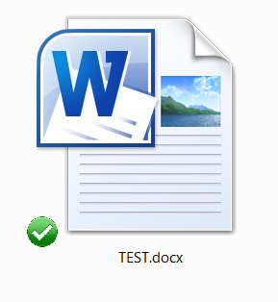

*Then I change the file extension to* ***.wxyz****, and the file icon change to the image presented below.*

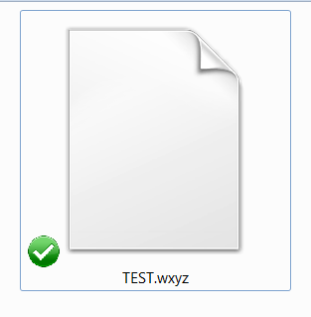

*When I left clicked on the above icon, the dialog box presented at the end of this paragraph, opened. It essentially indicated that Windows could not open the file, because it did not know what program to use. See the exact words on the following dialog box.*

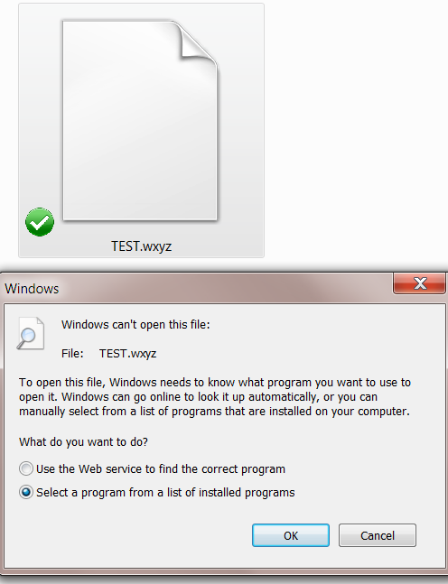

*After this, I clicked on the OK button, shown above, and another dialog box open, which is presented below.*

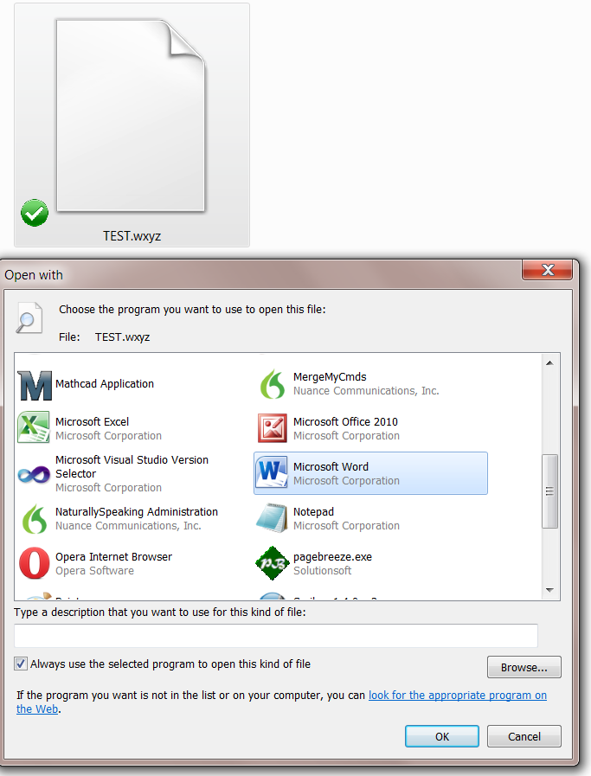

*From the above dialog box, I selected Microsoft Word, clicked on* ***OK.*** *When this was done, the dialog box closed and the* ***icon change to the image*** *presented below.*

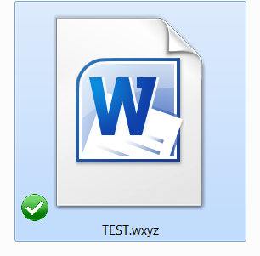

*When I clicked on the above icon, the file immediately opened. There was no change in the functionality of the file, and the content of the document did not change in any way. I saved the file with a few additional words, and closed it. When I reopened it the words that I added were retained, and so was the experimental file extension,****.wxyz****.*

*After completing the above, I created a blank Word document with the experimental extension, and the following filename:* ***Experiment-3.wxyz****. See the screenshot below.*

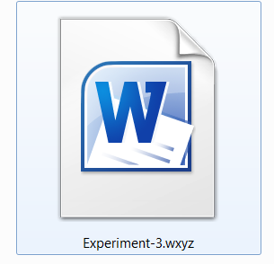

*I typed several lines of text into this document, and added some graphics, and saved it. I repeated this a number of times, and the contents was successfully saved, and the file name and the experimental file extension* ***.wxyz*** *was maintained by Microsoft Word.*

**From Other Authors: Additional and Supporting Information, and Alternative Perspectives, for Chapter 4**

**Instructions**

If you want more information, alternative perspectives or explanations, see the following websites and videos from other authors. To access this material left click on the blue links, or the URLs presented below.

**If a link fails**, enter the indicated **search phrase,** orthe \***words that are displayed from the website,** into the search engine presented on the left of each entry. If there are many words displayed from the website, select a few of the words that seem most useful for a search phrase. Then, carry out a conventional web-based search.

*Note the words from the website are indicated with **Words on website:** If you examine the following entries all of the above will be clarified.

**Webpages from other Authors, to Support and Supplement The Concepts and other Material in Chapter 4**

[**www.Google.com**](http://www.Google.com) **Search phrase:** [**“The best file formats” for writing**](https://www.google.com/#q=%E2%80%9CThe+best+file+formats%E2%80%9D+for+writing) **This is a Google search page, which indicates 4,880,000 results.**

**www.Google.com Words on website:** [**ImageMagick v6 Examples- Common Image Formats**](http://www.imagemagick.org/Usage/formats) **URL is:** [**http://goo.gl/LG8tCJ**](http://goo.gl/LG8tCJ)

**www.Google.com Words on website:** [**OpenOffice, File formats**](https://wiki.openoffice.org/wiki/Documentation/OOoAuthors_User_Manual/Getting_Started/File_formats) **URL is:** [**http://goo.gl/xOJ699**](http://goo.gl/xOJ699)

**www.Google.com Words on website:** [**File format reference for Office 2013**](http://technet.microsoft.com/en-us/library/dd797428.aspx) **URL is:**  [**http://goo.gl/XzDEZh**](http://goo.gl/XzDEZh)

**www.Google.com Words on website:** [**Use Word to open or save a file in another file format**](http://office.microsoft.com/en-us/word-help/use-word-to-open-or-save-a-file-in-another-file-format-HA010370113.aspx) **URL is:** [**http://goo.gl/ZjGgom**](http://goo.gl/ZjGgom)

**www.Google.com Words on website:** [**Use Word to open or save a file in another file format**](http://coe.unm.edu/uploads/docs/coe-main/tutorials/file-migration.pdf) **URL is:** [**http://goo.gl/YZK0KA**](http://goo.gl/YZK0KA)

**www.Google.com Words on website:** [**What are file extensions?**](http://www.bbc.co.uk/webwise/guides/file-extensions) **URL is:** [**http://goo.gl/VldWpH**](http://goo.gl/VldWpH)

**Videos from other Authors, to Support and Supplement The Concepts and other Material in Chapter 4**

When you left click on a **link** for a video, a webpage will open, and the video will start automatically in most cases. The webpage that opens with the video will usually have 10 or more **RELEVANT** videos. If the video does not start automatically, and the webpage opens, left click on the link provided by the author of the video. This link is usually in the center of the screen.

[**www.Video.Google.com**](http://www.Video.Google.com) **Search phrase:** [**“The best file formats” for writing**](https://www.google.com/search?tbm=vid&hl=en&source=hp&biw=&bih=&q=%E2%80%9CThe+best+file+formats%E2%80%9D+for+writing&gbv=2&oq=%E2%80%9CThe+best+file+formats%E2%80%9D+for+writing&gs_l=video-hp.12...0.0.1.78857.0.0.0.0.0.0.0.0..0.0....0...1ac..34.video-hp..1.0.0.tld_3ErQl9o)**, This is a Google video search page, which indicates 373 results.**

[**www.Video.Google.com**](http://www.Video.Google.com) **Words on website:** [**Computer PDF**](http://www.youtube.com/playlist?list=PLF009308AF648A439)**, URL is:** [**http://goo.gl/HICZkL**](http://goo.gl/HICZkL)

[**www.Video.Google.com**](http://www.Video.Google.com) **Words on website:** [**Web Design**](http://www.youtube.com/playlist?list=PL66A807E5724E3E5E)**, URL is:** [**http://goo.gl/p7Oysn**](http://goo.gl/p7Oysn)

[**www.Video.Google.com**](http://www.Video.Google.com) **Words on website:** [**APA Paper Microsoft Word 2013**](http://youtu.be/oyCexGBT_5o)**, URL is:** [**http://youtu.be/oyCexGBT_5o**](http://youtu.be/oyCexGBT_5o)

**www.Video.Google.com Search phrase,** [**“Microsoft Word”**](https://www.google.com/search?tbm=vid&hl=en&source=hp&biw=&bih=&q=%E2%80%9CMicrosoft+Word%E2%80%9D&gbv=2&oq=%E2%80%9CMicrosoft+Word%E2%80%9D&gs_l=video-hp.4..0l10.28429.28429.0.28854.1.1.0.0.0.0.74.74.1.1.0....0...1ac.1.34.video-hp..0.1.74.u0981lU8nHI#gbv=2&hl=en&q=%E2%80%9CMicrosoft+Word%E2%80%9D&tbm=vid) **This is a Google video search page, which indicates 10,600,000 results.**

[**www.Video.Google.com**](http://www.Video.Google.com) **Words on website:** [**Word 2013 Essential Training with David Rivers**](http://www.lynda.com/Office-tutorials/Word-2013-Essential-Training/115862-2.html)http://s.ytimg.com/yts/img/pixel-vfl3z5WfW.gif**, URL is:** [**http://goo.gl/bGBhvg**](http://goo.gl/bGBhvg)

[**www.Video.Google.com**](http://www.Video.Google.com) **Words on website:** [**Microsoft Word 2013 pt 7 (Table of Contents, Bibliography, Endnote**](http://www.youtube.com/watch?v=7Nx6UCJyv2A) **, URL is:** [**http://goo.gl/FVTOht**](http://goo.gl/FVTOht)

[**www.Video.Google.com**](http://www.Video.Google.com) **Search phrase:** [**OpenOffice.org 4**](https://www.google.com/search?tbm=vid&hl=en&source=hp&biw=&bih=&q=OpenOffice.org&gbv=2&oq=OpenOffice.org&gs_l=video-hp.3..0l6j0i5.2915.6856.0.10555.2.2.0.0.0.0.60.110.2.2.0....0...1ac.1.34.video-hp..0.2.109.HFlDLt9uEqU#gbv=2&hl=en&q=OpenOffice.org+4&tbm=vid)**, This is a Google video search page, which indicates 2,620,000 results.**

[**www.Video.Google.com**](http://www.Video.Google.com) **Words on website:** [**Open office 4 writer beginners tutorial - DCP Web Designers Tutorial**](http://www.youtube.com/watch?v=pI53WCpAJ3Y)

**URL is:** [**http://youtu.be/pI53WCpAJ3Y**](http://youtu.be/pI53WCpAJ3Y)

[**www.Video.Google.com**](http://www.Video.Google.com)[**Words on website:** **Microsoft Office vs OpenOffice / LibreOffice**](http://youtu.be/sloEMUt7n5Q)**, URL is:** [**http://youtu.be/sloEMUt7n5Q**](http://youtu.be/sloEMUt7n5Q)

**www.Video.Google.com Search phrase:** [**Libreoffice 4.2 OR 4.1 OR  4**](https://www.google.com/search?tbm=vid&hl=en&source=hp&biw=&bih=&q=%E2%80%9CMicrosoft+Word%E2%80%9D&gbv=2&oq=%E2%80%9CMicrosoft+Word%E2%80%9D&gs_l=video-hp.4..0l10.28429.28429.0.28854.1.1.0.0.0.0.74.74.1.1.0....0...1ac.1.34.video-hp..0.1.74.u0981lU8nHI#gbv=2&hl=en&q=Libreoffice+4.2+OR+4.1+OR+4&tbm=vid)**, This is a Google video search page, which indicates 852,000 results.**

[**www.Video.Google.com**](http://www.Video.Google.com) **Words on website:** [**LibreOffice 4 How To: add footnotes and endnotes**](http://youtu.be/nSvvv1Sm62s,%20URL%20is)**, URL is:** [**http://youtu.be/nSvvv1Sm62s**](http://youtu.be/nSvvv1Sm62s)

[**www.Video.Google.com**](http://www.Video.Google.com) **Words on website:** [**LibreOffice 4 How To: customize toolbars**](http://youtu.be/nSvvv1Sm62s,%20URL%20is)**, URL is:** [**http://youtu.be/nSvvv1Sm62s**](http://youtu.be/nSvvv1Sm62s)

[**www.Video.Google.com**](http://www.Video.Google.com) **Words on website:** [**LibreOffice 4 unter Windows 8 Installiert**](http://youtu.be/gaBjPEU3b9A)**, URL is:** [**http://youtu.be/gaBjPEU3b9A**](http://youtu.be/gaBjPEU3b9A)

[**www.Video.Google.com**](http://www.Video.Google.com) **Words on website:** [**LibreOffice web based**](http://youtu.be/xY_0_ojrUrQ) **, URL is:** [**http://youtu.be/xY_0_ojrUrQ**](http://youtu.be/xY_0_ojrUrQ)

**To go to the first page of this**

**chapter left click on these words.**

**HYPERLINK TABLE OF CONTENTS**

Below is the hyperlink table of contents of this chapter. If you left click on a section, or subsection, it will appear on your computer screen. Note the chapter heading, the yellow highlighted sections, and the blue subheadings are **all active links.**

File Formats, and Their Utility and Properties 2

What are File Formats? 2

The Utility of Word Processor Software that can Produce Multiple File Formats, for Creating Web-Based Documents 5

Microsoft Word, and Multiple File Formats 5

OpenOffice, and LibreOffice with Multiple File Formats 6

The Purpose of File Extensions, and How They Function 9

What Are File Extensions? 9

What is the Purpose of File Extensions 10

An Experiment Involving File Extensions, with Microsoft Word 2010, and Windows, Version 7 11

From Other Authors: Additional and Supporting Information, and Alternative Perspectives, for Chapter 4 19

Instructions 19

Webpages from other Authors, to Support and Supplement The Concepts and other Material in Chapter 4 21

Videos from other Authors, to Support and Supplement The Concepts and other Material in Chapter 4 22

**To go to the first page of this**

**Chapter, left click on these words.**

**If you want to go to the next chapter**

**left click on the link below**

[**www.TechForText.com/MW/Chapter-5/Word.docx**](http://www.TechForText.com/MW/Chapter-5/Word.docx)

**If you want to see a list of all**

**the chapters in this e-book go to**

[**www.TechForText.com/MW**](http://www.TechForText.com/MW)