

**Multiple Writing Strategies for Hardcopy, and**

**For Creating Web-Based E-Books and Articles**

**By David Alderoty © 2014**

**Chapter 5) File Formats on the Web, and**

**The Utility for the Writer of Electronic Documents**

**2,232 Words**

**[To contact the author left click for a](http://www.david100.com/Mail)**

**[website communication form, or use](http://www.david100.com/Mail)**

**E-mail: David@TechForText.com**

**If you want to go to the previous chapter,**

**left click on the link below**

[**www.TechForText.com/MW/Chapter-4/Word.docx**](http://www.TechForText.com/MW/Chapter-4/Word.docx)

**If you want to go to the table of contents**

**for this chapter left click on these words**

**File Formats I Tested for the Web**

**What Are the File Formats that Can Function From the World Wide Web**

I tested 21 file formats to determine if they can be accessed and opened from the web, with conventional hyperlinks. You can test these files yourself, because they were left permanently on the web server, and the hyperlinks are presented in this chapter.

If you are not using the same hardware and software I used, you might get different results.

**The Hardware and Software I Used**

For this test I used a Windows based commercial Web Server, and a Dell Inspiration 560 computer, running Windows 7. (The server consists of rented server space, which serves multiple accounts.) I performed the tests with three web browsers, which are Internet Explorer 9, Google Chrome 33, and Firefox 27.

To access the non-HTML files requires more than a web browser. I use the software that is available with Windows 7, Microsoft Office 2010, and the ACDSee Photo Manager 2009, to view or listen to the files.

**Three Categories of Files Tested For The Web**

**The Test Files, I Uploaded to the Web Server**

The test involved three categories of files, which are useful for writing web-based e-books and articles with graphics, and/or sound recordings, which are as follows:

**1)Tested Files for Text Documents**

I tested eleven document files. Ten of these files contained several sentences, a hyperlink, a textured brown background, and two photographs. One of the test files, (plain text format) only contained text, because it does not support hyperlinks or graphics.

**2) Files for Graphics**

I tested eight file formats for graphics, which **were NOT embedded in webpages or documents**. One of the graphics is a simple GIF animation, which I created with a program called Xara. Seven of the files involved JPEG photographs that I took several years ago, which were available on my websites. I converted six of the JPEG files to other file formats, with an application called ACDSee Photo Editor 2008.

**3) Files for Sound Recordings**

I tested two file formats for sound recordings, which were not embedded in webpages or documents. The test recordings start when the user clicks on a hyperlink.

**The Display of the Files in the Web Browsers**

Firefox displayed the files in a superior way, especially the individual graphic files, which included photographs. Internet Explorer and Google Chrome display the graphics on the left side of the screen. Firefox displayed the images in the center of the screen, with an attractive black background.

If you want to obtain Firefox go to [www.mozilla.org](http://www.mozilla.org) If you want Google Chrome go to [www.google.com/chrome](http://www.google.com/chrome) If you want Internet Explorer go to [www.microsoft.com](http://www.microsoft.com)

**The Test Results**

**Files that Functioned Over the Web**

Nineteen of the 21 files I tested opened, when I clicked on their hyperlinks. The two files that did **not** open are the OpenDocument Text (.odt), and the JPEG2000 (.jp2).

Note: You will probably find that four or five files will not open on your computer, unless you have photo software that can open some of the unusual graphic formats, such as ACDSee Photo Manager 2009.

Most of the non‑HTML files, took longer to open, then a conventional webpage, and in most cases required clicking on a dialog box, such as one of the following:

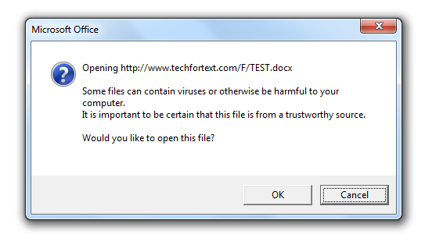

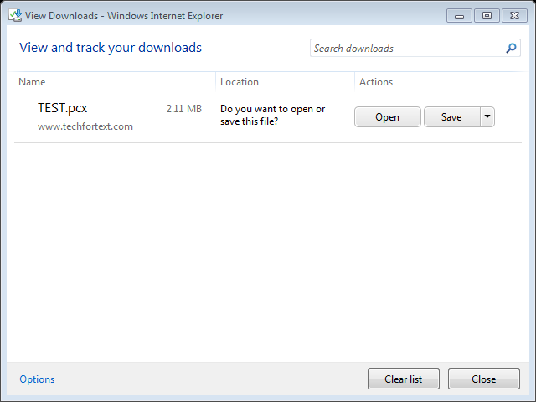

After clicking on the **OK** or **Open** button, most

of the files opened in less than 20 seconds.

**My Conclusions and the General Principle**

**Results Based on a Server Running Windows**

Keep in mind that I ran these tests with **only one** Windows-based web server. The results **might** be different with another server, especially if it is a Linux-based server. However, I cannot discern any reason why a server running Linux would produce different results.

**Conclusions, and How to Create Web Addresses for Almost Any File Format**

Based on my test results, I conclude that most file formats can probably be accessed from the web, with conventional hyperlinks, if the web addresses are configured as follows:

**Domain**/**Folder**/**Filename.Extension**

For example, I use the domain **www.TechForText.com**, and the folder that holds the file I am naming **F.** For this example, I am using the filename **TEST**. Let us assume that the file extension is **.jpg**. Based on the above the web address is:

[**www.TechForText.com/F/TEST.jpg**](http://www.TechForText.com/F/TEST.jpg)

**If you copy and paste the above into the address bar of your web browser, or left click on it, a file will open from the web.**

**The Results Based on Each File Tested**

**Text Documents on the Web**

I tested eleven text document file formats, all of which were created with Microsoft Word. One of the files contained only text, and the remaining ten contained the following:

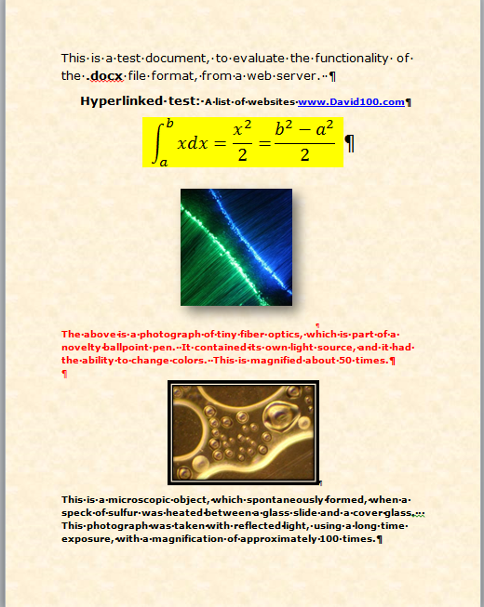

The eleven files and their hyperlinks are listed in the following paragraphs:

1) [www.TechForText.com/F/TEST.docx](http://www.TechForText.com/F/TEST.docx)

This file opened in approximately 44 seconds. When I repeated the test about a minute later, the file opened in about 5 seconds. When I retested several hours later, the file opened in about 30 seconds. This is the conventional Microsoft Word file format, which is available in Word 2007-2010, and 2013. It can be easily converted to the other file formats presented in this subsection.

2) [www.TechForText.com/F/TEST.doc](http://www.TechForText.com/F/TEST.doc)

This file opened in approximately 6 to 9 seconds, based on two trials. This is the older version of the Microsoft Word file format, originally used in Word 1997‑2003

3) [www.TechForText.com/F/TEST.rtf](http://www.TechForText.com/F/TEST.rtf)

This file opened in approximately 10 seconds. This is the Rich Text File Format. This file format was originally created by Microsoft, but it can be opened with many applications.

4) [www.TechForText.com/F/TEST.xml](http://www.TechForText.com/F/TEST.xml)

This file opened in approximately 7 seconds. This is Microsoft’s version of XML, and it is available in Word 2010. Microsoft's XML has about the same formatting functionality as a conventional word document.

5) [www.TechForText.com/F/TEST.pdf](http://www.TechForText.com/F/TEST.pdf)

This file opened in approximately 12 seconds. This is a PDF document, which was created in Microsoft Word, by converting a conventional word document. Microsoft Word cannot be used to edit or view a PDF document. However, the original Word document is maintained when a PDF is created.

6) [www.TechForText.com/F/TEST.xps](http://www.TechForText.com/F/TEST.xps)

This file opened in about 8 seconds. This file format was invented by Microsoft, and it is very similar to PDF in functionality. However, you cannot use a PDF reader to view this file format. This file format requires a XPS viewer. If you do not have this viewer on your system see the following:

URL [www.microsoft.com/en-us/download/details.aspx?id=11816](http://www.microsoft.com/en-us/download/details.aspx?id=11816)

For Windows 8 see <http://youtu.be/jN9GlDIAyd8>

7) [www.TechForText.com/F/TEST.htm](http://www.TechForText.com/F/TEST.htm)

This file opened in approximately 1 to 4 seconds, based on two trials. This is a HTML webpage, created with Microsoft Word.

8) [www.TechForText.com/F/TEST-Filtered.htm](http://www.TechForText.com/F/TEST-Filtered.htm)

This file opened in approximately 1 to 2 seconds, based on two trials. This is a filtered version of Microsoft Word’s HTML, which does not include some of the extraneous code that is present in the unfiltered version mentioned above. The filtered HTML version has some advantages for the web, it results in a smaller file size, and it might open in less time than the unfiltered version. The filtered version might provide better search engine functionality, because the unusual Microsoft code is filtered out.

**NOTE:** The code that is filtered out is only needed for formatting and editing. Thus, once you convert a Word document to the filtered version of HTML, you will encounter some editing difficulties. For example, you cannot modify the table of contents, or mathematical expressions, when you reopen a filtered HTML webpage. However, you can re-create the table of contents, mathematical expressions, and other formatting, when the filtered version is reopened. In general, it is wise to keep the original Word document when converting to the filtered version of HTML.

9) [www.TechForText.com/F/TEST.mht](http://www.TechForText.com/F/TEST.mht)

This file opened in approximately 2 seconds. This is a file format invented by Microsoft, and it is called the single file webpage. Unlike conventional HTML webpages, this file format is designed to store the graphics and text in a single file. This file format can only be opened with Internet Explorer, and other web browsers might be able to open it, with a special plug-in.

When I tried to access this file with Firefox, a dialog box was displayed, with two choices, which were Internet Explorer, or Microsoft Word. When I tried to access it with Google Chrome, the file was automatically downloaded, but to open it required Internet Explorer.

When this file was opened the majority of the times a yellow background was displayed, instead of the light brown textured background I used, when creating this webpage. However, when I left clicked on the upper portion of the address bar, and then press the enter key, the brown textured background appeared.

10) [www.TechForText.com/F/TEST.txt](http://www.TechForText.com/F/TEST.txt)

This file opened in approximately 4 seconds. This is the Plane Text File Format. This format does not support graphics, and when I accessed it with the above hyperlink, all the formatting including text size, was eliminated. The font that was displayed appeared about 8pt. When I created this document, I used a font size of 48pt.

11) [www.TechForText.com/F/TEST.odt](http://www.TechForText.com/F/TEST.odt)

This is the OpenDocument Text (.odt) file format, and it did **NOT** open from the web. I tried to open it with Internet Explorer, Google Chrome, and Firefox, and it did not open. Then I tested the file to determine if it was damaged, with a FPT connection directly to the server. As soon as I clicked on the icon, the file opened normally. This indicates that OpenDocument Text (.odt) cannot be opened from the web (with the software and hardware I used).

**Graphics and Photographs**

I tested eight file formats for graphics, which **were NOT embedded in webpages or documents**. One of the graphics is a simple GIF animation, which I created for test purposes. Seven of the files involved JPEG photographs that I took several years ago, which were available on my websites. I converted six of the JPEG files to other file formats, with software available on my computer.

1) [www.TechForText.com/F/TEST.jpg](http://www.TechForText.com/F/TEST.jpg)

This file opened in approximately 5 seconds, and it is called JPEG. This is a very common file format for photographs, and it functioned very well from the web, in spite of the fact that it it was not embedded in a webpage.

2) [www.TechForText.com/F/TEST.gif](http://www.TechForText.com/F/TEST.gif)

This file opened in approximately 5 seconds, and it is a GIF file, also called the Graphics Interchange Format. This is a relatively compact bitmap format, with a palette of 256 colors. This is an ideal format for drawings and sketches, but it is not suitable for high quality photographic images.

3) [www.TechForText.com/F/Animation.gif](http://www.TechForText.com/F/Animation.gif)

This file opened in approximately 4 seconds. This file format is similar to the above, except it is a GIF **animation**. This has the same file extension as above. However, it is comprised of multiple images that are automatically displayed in a repeating cycle. I created this animation for test purposes, with a program called Xara.

4) [www.TechForText.com/F/TEST.pcx](http://www.TechForText.com/F/TEST.pcx)

This file opened successfully in approximately 8 seconds. This is a PCX file, and it is a bitmap graphics file. When I clicked on the above hyperlink, this file accessed photo-editing software I have on my computer, through the web browser, called ACDSee Photo Editor 2008. I was not able to open this file with the other software on my computer.

5) [www.TechForText.com/F/TEST.tif](http://www.TechForText.com/F/TEST.tif)

This file opened in approximately 6 seconds. This is the

TIFF, or Tagged Image File Format. TIFF is a versatile graphics file format that can be compressed, and it is useful for drawings, sketches, and photographs.

6) [www.TechForText.com/F/TEST.bmp](http://www.TechForText.com/F/TEST.bmp)

This file opened in approximately 8 seconds. This is a bitmap file, commonly used in Windows, as well as other operating systems. This file format is useful for high quality images, but it produces relatively large file sizes, and these files cannot be compressed, unless it is converted to, another file formats such as JPEG. For test purposes, I converted this file to JPEG, and it went from 2.18 MB to 120 KB.

7) [www.TechForText.com/F/TEST.jp2](http://www.TechForText.com/F/TEST.jp2)

This file did **not** open, when I clicked on the hyperlink. I also entered the above URL into the address box of Internet Explorer, Google Chrome, and Firefox, and it still did not open. Then I tested the file, directly from the server, with a FTP connection, to determine if it was functioning properly. As soon as I clicked on the icon and a dialog box, the file opened. Thus, this file does not appear to function from the web (with the software and hardware I was using).

8) [www.TechForText.com/F/TEST.wbmp](http://www.TechForText.com/F/TEST.wbmp)

This file opens successfully, in approximately 5 seconds. The WBMP file format only provides black and white renditions, and it was originally created for wireless communication devices.

**File Formats For Sound Recordings**

The audio for the two sound files that were tested, was electronically generated, by the direct conversion of conventional text to an audio format. To create an MP3 file, I used an application called TextAloud, and to create a Wave file, I used an application called Hal Reader.

1) [www.TechForText.com/F/TEST.mp3](http://www.TechForText.com/F/TEST.mp3)

This file opened in approximately 4 seconds. This is the MP3 file format, which can store sound recordings very compactly. The above hyperlink starts a sound recording that is only 75.5 KB. Compare this with the size of the wave file presented below.

2) [www.TechForText.com/F/TEST.wav](http://www.TechForText.com/F/TEST.wav)

This file opened in approximately 9 seconds. This is a Wave file, which is much larger than the above at 616 KB, but it contains approximately the same audio content.

**From Other Authors: Additional and Supporting Information, and Alternative Perspectives, for Chapter 6**

**Instructions**

If you want more information, alternative perspectives or explanations, see the following websites and videos from other authors. To access this material left click on the blue links, or the URLs presented below.

**If a link fails**, enter the indicated **search phrase,** orthe \***words that are displayed from the website,** into the search engine presented on the left of each entry. If there are many words displayed from the website, select a few of the words that seem most useful for a search phrase. Then, carry out a conventional web-based search.

*Note the words from the website are indicated with **Words on website:** If you examine the following entries all of the above will be clarified.

**Webpages from other Authors, to Support and Supplement The Concepts and other Material in Chapter 6**

**www.Google.com Search phrase:** [**file formats for the web**](https://www.google.com/#q=file+formats+for+the+web&start=0) **This is a Google search page, which indicates 54,400,000 results results.**

**www.Google.com Words on website:** [**Graphic File Formats**](http://webstyleguide.com/wsg3/11-graphics/5-web-graphics-formats.html)**, URL is** [**http://goo.gl/5GGe0D**](http://goo.gl/5GGe0D)

**www.Google.com Words on website:** [**Which Graphics File Format Is Best To Use When?**](http://graphicssoft.about.com/od/graphicformats/f/summary.htm) **By Sue Chastain URL is** [**http://goo.gl/7z9sv0**](http://goo.gl/7z9sv0)

**www.Google.com Words on website:** [**What is the best image file type to use on a website?**](http://digitalpark.com/26_what-is-the-best-image-file-type-to-use-on-a-website) **URL is:** [**http://goo.gl/jY8byn**](http://goo.gl/jY8byn)

**www.Google.com Words on website:** [**HowTo.gov Using Appropriate File Formats**](http://www.howto.gov/web-content/accessibility/file-formats) **URL is:** [**http://goo.gl/41xtcI**](http://goo.gl/41xtcI)

**www.Google.com Words on website:** [**Choosing the best graphic format for the job**](http://office.microsoft.com/en-us/help/choosing-the-best-graphic-format-for-the-job-HA001056305.aspx)**, URL is** [**http://goo.gl/IyhPka**](http://goo.gl/IyhPka)

**Videos from other Authors, to Support and Supplement The Concepts and other Material in Chapter 6**

When you left click on a **link** for a video, a webpage will open, and the video will start automatically in most cases. The webpage that opens with the video will usually have 10 or more **RELEVANT** videos. If the video does not start automatically, and the webpage opens, left click on the link provided by the author of the video. This link is usually in the center of the screen.

[**www.Video.Google.com**](http://www.Video.Google.com) **Search phrase:** [**file formats for the web**](https://www.google.com/search?tbm=vid&hl=en&source=hp&biw=&bih=&q=file+formats+for+the+web&gbv=2&oq=file+formats+for+the+web&gs_l=video-hp.12...2341.2341.0.3800.1.1.0.0.0.0.52.52.1.1.0....0...1ac.1.34.video-hp..1.0.0.uacvFccgQZY#gbv=2&hl=en&q=file+formats+for+the+web&tbm=vid)**, This is a Google video search page, which indicates 491,000 results.**

[**www.Video.Google.com**](http://www.Video.Google.com) **Words on website:** [**Understanding web file formats**](http://www.lynda.com/Photoshop-tutorials/Understanding-web-file-formats/105368/109074-4.html) **, URL is** [**http://goo.gl/t1MZF2**](http://goo.gl/t1MZF2)

[**www.Video.Google.com**](http://www.Video.Google.com) **Words on website:** [**Image File Formats for Web Pages, What format does What**](http://www.youtube.com/watch?v=VkGp-Ee6RJA) **, URL is:** [**http://youtu.be/VkGp-Ee6RJA**](http://youtu.be/VkGp-Ee6RJA)

[**www.Video.Google.com**](http://www.Video.Google.com) **Words on website:** [**Web Video File Formats**](http://www.youtube.com/watch?v=hHXug-05w4Q)**, URL is:** [**http://youtu.be/hHXug-05w4Q**](http://youtu.be/hHXug-05w4Q)

**To go to the first page of this**

**chapter left click on these words.**

**HYPERLINK TABLE OF CONTENTS**

Below is the hyperlink table of contents of this chapter. If you left click on a section, or subsection, it will appear on your computer screen. Note, the yellow highlighted sections, and the blue subheadings are **all active links.**

File Formats I Tested for the Web 2

What Are the File Formats that Can Function From the World Wide Web 2

The Hardware and Software I Used 3

Three Categories of Files Tested For The Web 4

The Test Files, I Uploaded to the Web Server 4

1)Tested Files for Text Documents 5

2) Files for Graphics 5

3) Files for Sound Recordings 7

The Display of the Files in the Web Browsers 7

The Test Results 8

Files that Functioned Over the Web 8

My Conclusions and the General Principle 11

Results Based on a Server Running Windows 11

Conclusions, and How to Create Web Addresses for Almost Any File Format 11

The Results Based on Each File Tested 13

Text Documents on the Web 13

Graphics and Photographs 26

From Other Authors: Additional and Supporting Information, and Alternative Perspectives, for Chapter 6 36

Instructions 36

Webpages from other Authors, to Support and Supplement The Concepts and other Material in Chapter 6 37

Videos from other Authors, to Support and Supplement The Concepts and other Material in Chapter 6 39

**To go to the first page of this**

**chapter left click on these words.**

**If you want to go to the next chapter**

**left click on the link below**

[**www.TechForText.com/MW/Chapter-6/Word.docx**](http://www.TechForText.com/MW/Chapter-6/Word.docx)

**If you want to see a list of all**

**the chapters in this e-book go to**

**[www.TechForText.com/MW](http://www.TechForText.com/MW)**