

**Concepts in Mathematics**

**By David Alderoty © 2015**

**Chapter 6) Algebra, Definitions, Axioms, And Solving Equations**

**over 2,500 words**

[**To contact the author left click for a**](http://www.David100.com/Mail)

[**website communication form, or use:**](http://www.David100.com/Mail)

**[David@TechForText.com](mailto:David@TechForText.com)**

**To go to the previous chapter**

**left click on one of the following links:**

[**For HTML**](http://www.TechForText.com/Ma/Chapter-5)

[**www.TechForText.com/Ma/Chapter-5**](http://www.TechForText.com/Ma/Chapter-5)

[**For PDF**](http://www.TechForText.com/Ma/Chapter-5/PDF.pdf)

[**www.TechForText.com/Ma/Chapter-5/PDF.pdf**](http://www.TechForText.com/Ma/Chapter-5/PDF.pdf)

**If you want to go to the table of contents**

**of this CHAPTER left click on these words**

**To Access Additional Information with Hyperlinks**

After I complete a writing task, I select a number of websites from other authors, and link to them, to provide additional information and alternative perspectives for the reader. The links are the blue underlined words, and they can be seen throughout this e‑book. The [in‑line links, such as the link on these words](http://www.currybet.net/cbet_blog/2008/08/bbc-news-in-line-text-links-tr.php), are primarily to support the material I wrote, or to provide additional details. The links presented at the end of some of the paragraphs, subsections, and sections are primarily for websites with additional information, or alternative points of view, or to support the material I wrote. The websites contain articles, videos, and other useful material.

The brown text that look like these fonts, represent quotes in this book. **You can access the original source, by clicking on a link presented just before a quote.**

If a link fails, use the blue underlined words as a search phrase, with [www.Google.com](http://www.Google.com). If the failed link is for a video use [www.google.com/videohp](http://www.google.com/videohp). The search will usually bring up the original website, or one or more good alternatives.

**Definitions of Algebra, and Related Concepts**

**Conventional Definitions of Algebra**

A simplified definition of algebra is a branch of mathematics that deals with equations and inequalities that have one or more unknown values, which are usually represented by letters, such as X, Y, and Z. Listed below there are three additional definitions of algebra from online dictionaries. Note, if you want more details from these dictionaries click on the blue underlined links, to access the original source.

From the Marriam‑Webster online dictionary, website is:

[www.merriam-webster.com/dictionary/algebra](http://www.merriam-webster.com/dictionary/algebra)

Full Definition of ALGEBRA

1**:**  a generalization of arithmetic in which letters representing numbers are combined according to the rules of arithmetic

2**:**  any of various systems or branches of mathematics or logic concerned with the properties and relationships of abstract entities (as complex numbers, matrices, sets, vectors, groups, rings, or fields) manipulated in symbolic form under operations often analogous to those of arithmetic — compare [boolean algebra](http://www.merriam-webster.com/dictionary/boolean+algebra)

From the *Collins English Dictionary - Complete & Unabridged 10th Edition*. Retrieved from Dictionary.com website: <http://dictionary.reference.com/browse/algebra>

British Dictionary definitions for algebra

1. a branch of mathematics in which arithmetical operations and relationships are generalized by using alphabetic symbols to represent unknown numbers or members of specified sets of numbers

2. the branch of mathematics dealing with more abstract formal structures, such as sets, groups, etc

From *The American Heritage® Science Dictionary* Retrieved from Dictionary.com, the website is <http://dictionary.reference.com/browse/algebra>

Algebra in Science

A branch of mathematics in which symbols, usually letters of the alphabet, represent numbers or quantities and express general relationships that hold for all members of a specified set.

**A Detailed Descriptive Definition of Algebra**

(Note, this definition required two paragraphs.) Based on the way I am using the terminology, algebra is a branch of mathematics that deals with equations and inequalities, including formulas, that have unknown values, and related techniques for determining the values of the unknowns. The values are usually represented by letters, but they can also be represented by words, such as in the following examples:

$\begin{matrix} 3X+34=334 \end{matrix}$, $\begin{matrix} 4+10Y<123 \end{matrix}$, and $\begin{matrix} Sin(60)+2X=Tan(60) \end{matrix}$

$For a rectangle:$ $\begin{matrix}Length times Width equals Area \end{matrix} or$

$$\left(Length\right)\left(Width\right)= Area$$

The techniques and related calculations in algebra include the following:

* Techniques for adding, subtracting, dividing, multiplying, and factoring numbers, and the symbols that represent unknown values
* Techniques for determining the value of the symbols that represent unknown quantities
* Techniques for graphing equations, and inequalities

**Twenty-Seven Examples of Equations, Inequalities, and Graphs of Equations and Inequalities**

**Following Six Examples are Equations that Contain Unknowns and Numbers**

$$\begin{matrix} \\ (Example 1) \\ \\ 2Y-100=Y \\ Y=100 \\ \end{matrix}$$

$$\begin{matrix} \\ (Example 2) \\ \\ 100Y=4(96+Y) \\ 100Y=384+4Y \\ \begin{matrix}100Y-4Y=384 \\ 96Y=384 \\ \begin{matrix} \\ Y=\frac{384}{96}=4 \\ \begin{matrix} \\ Y=4\end{matrix} \\ \end{matrix}\end{matrix}\end{matrix}$$

$$\begin{matrix} \\ (Example 3) \\ \\ X^{2}-50=50 \\ X^{2}=100 \\ X=±10 \\ \end{matrix}$$

$$\begin{matrix} \\ (Example 4) \\ \\ AX=A(99+1) \\ X=99+1 \\ X=100 \\ \end{matrix}$$

$$\begin{matrix} \\ (Example 5) \\ \\ AY+Y=10 \\ Y\left(A+1\right)=10 \\ \\ Y=\frac{10}{A+1} \\ \\ \begin{matrix} \\ Not enough information in this \\ equation to find the value of Y \\ \end{matrix}\end{matrix}$$

$$\begin{matrix} \\ (Example 6) \\ \\ WY=10 \\ Y=\frac{10}{W} \\ \begin{matrix} \\ Not enough information in this \\ equation to find the value of Y \\ \end{matrix}\end{matrix}$$

**The Following Three Examples are Equations that Contain Two or More Unknowns**

$$\begin{matrix} \\ (Example 7) \\ \\ A+B+X=3X+10A \\ X-3X=-A-B+10A \\ \begin{matrix}-2X=9A-B \\ \\ \begin{matrix}X=\frac{9A-B}{-2} \\ \\ X=\frac{B-9A}{2}\end{matrix} \\ \end{matrix}\end{matrix}$$

$$\begin{matrix} \\ (Example 8) \\ \\ SX+AB=D+W \\ \begin{matrix} SX=D+W-AB \\ \\ X=\frac{D+W-AB}{S} \\ \end{matrix}\end{matrix}$$

$$\begin{matrix} \\ (Example 9) \\ \\ \begin{matrix}100X+Sin\left(Q\right)-100B =A \\ 100X=-Sin\left(Q\right)+100B+A \\ \begin{matrix} \\ X=\frac{-Sin\left(Q\right)+100B+A}{100} \\ \end{matrix}\end{matrix}\end{matrix}$$

**The Following Three Examples are Inequalities**

$$\begin{matrix} \\ (Example 10) \\ \\ 10+Z>100 \\ Z>90 \\ \end{matrix}$$

$$\begin{matrix} \\ (Example 11) \\ \\ 100+Y>10 \\ Y>10-100 \\ Y>-90 \\ \end{matrix}$$

$$\begin{matrix} \\ (Example 12) \\ \\ 3X+5<100+X-1 \\ 2X<100-5-1 \\ \begin{matrix}2X<100-6 \\ 2X<94 \\ X<47 \\ \end{matrix}\end{matrix}$$

**The Following 15 Examples are Graphs of Equations and Inequalities**

The following examples were graphed electronically with [Microsoft Word’s Mathematics add-in](http://www.microsoft.com/en-us/download/details.aspx?id=36777). I change the colors of the graphs to improve aesthetics.

(Example 13) $y=x$

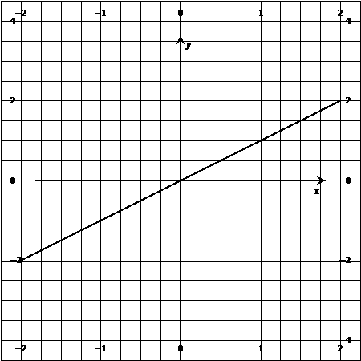

(Example 14) $y>x$

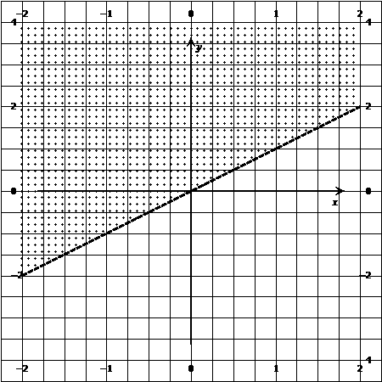

(Example 15) $y<x$

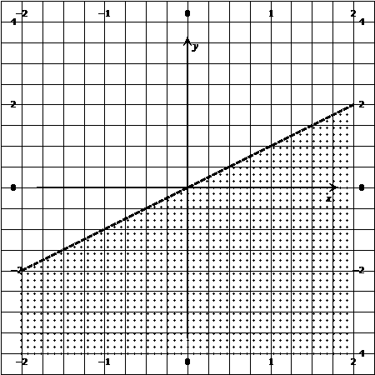

(Example 16) $y=x^{2}$

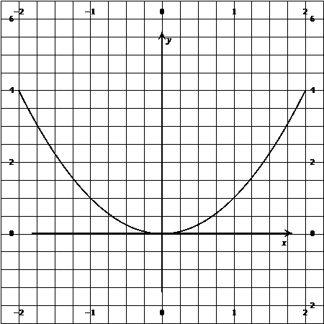

(Example 17) $y>x^{2}$

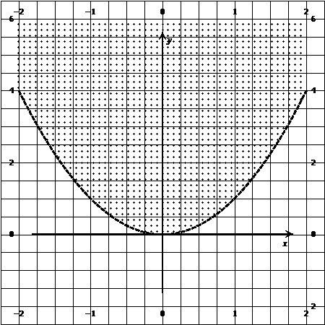

(Example 18) $y<x^{2}$

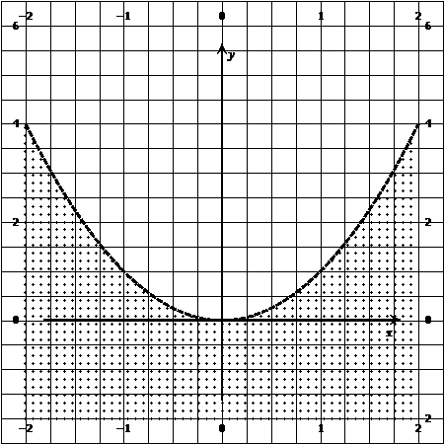

(Example 19) $y=x+2$

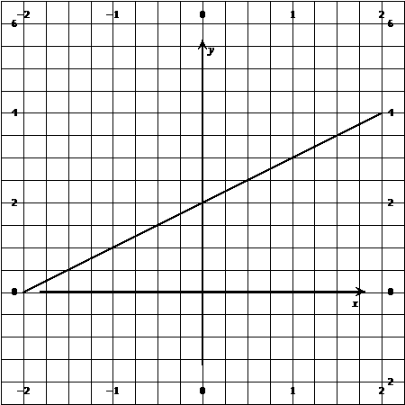

(Example 20) $y>x+2$

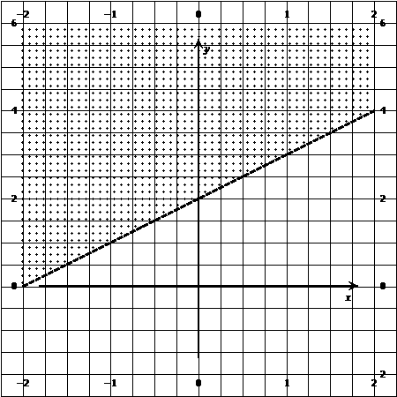

(Example 21) $y<x+2$

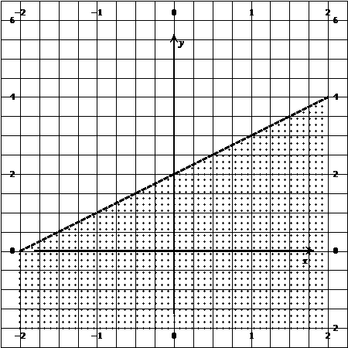

(Example 22) $y=x^{2}+2$

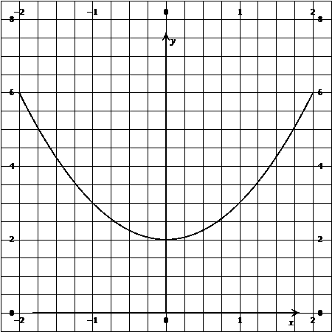

(Example 23) $y>x^{2}+2$

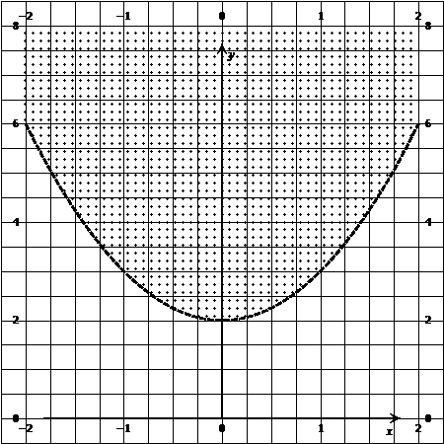

(Example 24) $y<x^{2}+2$

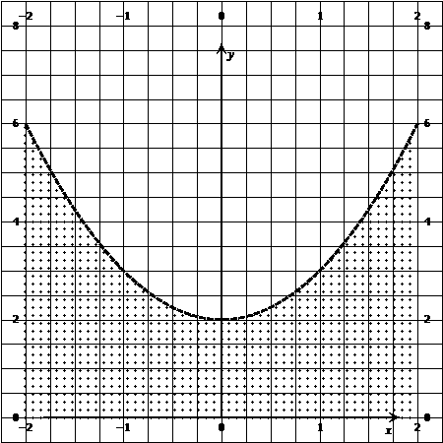

(Example 25) $y=sin⁡(x)$

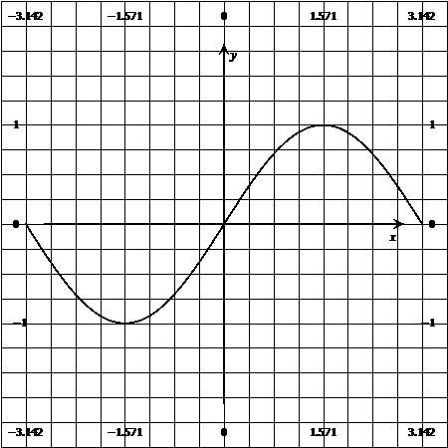

(Example 26) $y>sin⁡(x)$

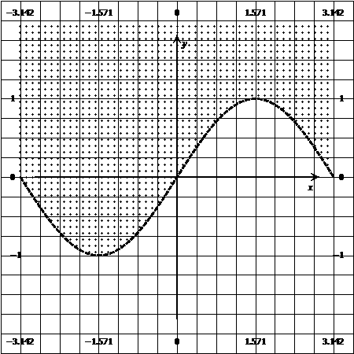

(Example 27) $y<sin⁡(x)$

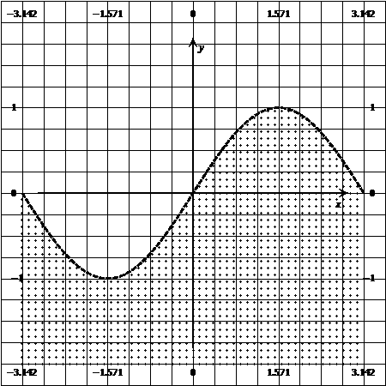

**Basic Concepts in Algebra, and Axioms and Theorems**

**Basic Concepts in Algebra**

The following **22 concepts** are typically used in algebra. Most of these concepts are true by definition.

$$\begin{matrix}(Concept 1) \\ X equals Y \\ X=Y\end{matrix}$$

$$\begin{matrix}(Concept 2) \\ X does not equal Z \\ X≠Z\end{matrix}$$

$$\begin{matrix}(Concept 3) \\ X is greater than Z \\ X>Z\end{matrix}$$

$$\begin{matrix}(Concept 4) \\ X is less than W \\ X<W\end{matrix}$$

$$\begin{matrix}\begin{matrix}(Concept 5) \\ All of the following represent \\ \begin{matrix}multiplication of A and B: \\ AB \\ \begin{matrix}A(B) \\ (A)(B) \\ \begin{matrix}A*B \\ A∙B \\ \begin{matrix}\left(A\right)*(B) \\ \left(A\right)∙(B)\end{matrix}\end{matrix}\end{matrix}\end{matrix}\end{matrix}\end{matrix}$$

$$\begin{matrix}(Concept 6) \\ A divided by B \\ \frac{A}{B} \\ \begin{matrix} \\ \begin{matrix}OR \\ A/B\end{matrix}\end{matrix}\end{matrix}$$

$$\begin{matrix}(Concept 7) \\ A plus B \\ A+B\end{matrix}$$

$$\begin{matrix}(Concept 8) \\ A minus B \\ A-(B)\end{matrix}$$

$$(Concept 9)$$

$$\begin{matrix}A negative number multiplied \\ by a positive number \\ -A\left(B\right)=-AB \\ A\left(-B\right)=-AB\end{matrix}$$

$$\begin{matrix}(Concept 10) \\ A negative number multiplied \\ by another negative number \\ -A\left(-B\right)=AB\end{matrix}$$

$$\begin{matrix}(Concept 11) \\ A negative number divided \\ by a positive number \\ \frac{-A}{B}=-\frac{A}{B}\end{matrix}$$

$$\begin{matrix}(Concept 12) \\ A negative number divided \\ by another negative number \\ \frac{-A}{-B}=\frac{A}{B}\end{matrix}$$

$$\begin{matrix}(Concept 13) \\ Multiplying a fraction by a negative number \\ \\ \begin{matrix}-N\left(\frac{A}{B}\right)=\frac{-NA}{B} \\ OR \\ \begin{matrix} \\ -N\left(\frac{A}{B}\right)=-\frac{NA}{B}\end{matrix}\end{matrix}\end{matrix}$$

$$\begin{matrix}(Concept 14) \\ Multiplying a negative fraction \\ by positive number \\ \begin{matrix} \\ \begin{matrix}B\left(\frac{-A}{C}\right)=-\frac{AB}{C} \\ OR \\ \\ -N\left(\frac{A}{B}\right)=\frac{-NA}{B}\end{matrix} \\ \end{matrix}\end{matrix}$$

$$\begin{matrix}(Concept 15) \\ If ZERO is multiplied or divided by \\ any number, the result is zero \\ \begin{matrix} \\ A\left(0\right)=0 \\ \\ and \\ \\ \frac{0}{A}=0\end{matrix}\end{matrix}$$

$$\begin{matrix}(Concept 16) \\ Dividing a number by zero results in one of the \\ following, depending on the context: \\ \\ \frac{A}{0}= Undefined \\ OR \\ \begin{matrix}\frac{A}{0}=Indeterminate, \\ OR \\ \begin{matrix}\frac{A}{0}=∞\end{matrix} \\ OR \\ \frac{A}{0}=Not permitted\end{matrix}\end{matrix}$$

The following concepts are demonstrated by substituting numbers for the variables.

$$\begin{matrix}Concept 17 \\ {\left(A+B\right)}^{2}=(A+B)(A+B) \\ \begin{matrix}{\left(3+4\right)}^{2}=(3+4)(3+4) \\ {\left(7\right)}^{2}=(7)(7) \\ 49=49\end{matrix}\end{matrix}$$

$$\begin{matrix}Concept 18 \\ {\left(C+E\right)}^{2}=C^{2}+2CE+E^{2} \\ \begin{matrix}{\left(5+7\right)}^{2}=5^{2}+2\left(5\right)\left(7\right)+7^{2} \\ {\left(12\right)}^{2}=25+70+49 \\ \begin{matrix}144=144\end{matrix}\end{matrix}\end{matrix}$$

$$\begin{matrix}Concept 19 \\ A+0=A \\ \begin{matrix}3+0=3 \\ 3=3 \\ \end{matrix}\end{matrix}$$

$$\begin{matrix}Concept 20 \\ A\left(\frac{1}{A}\right)=1 \\ \begin{matrix} \\ 3\left(\frac{1}{3}\right)=1 \\ 1=1\end{matrix}\end{matrix}$$

$$\begin{matrix}Concept 21 \\ -1(-E)=E \\ \begin{matrix}-1\left(-7\right)=7 \\ 7=7\end{matrix}\end{matrix}$$

$$\begin{matrix}Concept 22 \\ -1(+F)=-F \\ \begin{matrix}-1\left(8\right)=-8 \\ -8=-8\end{matrix}\end{matrix}$$

$$\begin{matrix}Concept 23 \\ \frac{A}{A}=1 \\ \begin{matrix} \\ \frac{3}{3}=1 \\ 1=1\end{matrix}\end{matrix}$$

**Algebraic Laws, are Important Concepts, But they are Not Really Laws**

The following seven illustrations, demonstrate basic concepts that are called laws by most sources. However, these concepts are actually basic algebraic axioms. Below this paragraph, there are seven illustrations of these concepts. I will demonstrate their validity, by substituting numbers for the variables, to show that the equality is maintained.

$$\begin{matrix}1) Associative Law \\ C(AB)=A(CB) \\ \begin{matrix}5(3)(4)=3(5)(4) \\ 5(12)=3(20) \\ 60=60\end{matrix}\end{matrix}$$

$$\begin{matrix}2) Associative Law \\ D+(G+F)=G+(D+F) \\ \begin{matrix}6+\left(9+8\right)=9+(6+8) \\ 6+\left(17\right)=9+(14) \\ 23=24\end{matrix}\end{matrix}$$

$$\begin{matrix}3) Associative Law \\ (G+A)-B =G+(A-B) \\ \begin{matrix}\left(9+3\right)-4=9+(3-4) \\ 12-4=9-1 \\ 8=8\end{matrix}\end{matrix}$$

$$\begin{matrix}4) Commutative Law \\ AB=BA \\ \begin{matrix}3(4)=4(3) \\ 12 =12\end{matrix}\end{matrix}$$

$$\begin{matrix} 5) Commutative Law \\ D+C=C+D \\ \begin{matrix}6+5=5+6 \\ 11=11\end{matrix}\end{matrix}$$

$$\begin{matrix}6) Distributive Law \\ A\left(G+F\right)=AG+AF \\ \begin{matrix}3\left(9+8\right)=3\left(9\right)+3\left(8\right) \\ 3\left(17\right)=27+24 \\ 51=51\end{matrix}\end{matrix}$$

$$\begin{matrix}7) Distributive Law \\ B(C-D)=BC-BD \\ \begin{matrix}4\left(5-6\right)=4\left(5\right)-4(6) \\ 4\left(-1\right)=20-24 \\ -4=-4\end{matrix}\end{matrix}$$

**Algebraic Axioms, Theorems, and Solving Equations**

**Algebraic Axioms and Theorems**

To carry out algebraic calculations and to solve equations, various types of axioms and theorems are used. Axioms are logical concepts that are apparent, and they can be confirmed experimentally. Theorems are logical concepts that are based on axioms, and they can be proved using logic.

Keep in mind axioms and theorems are **NOT** rules, they are logical concepts. With rules, you cannot logically create your own rules to solve your problems. However, with axioms and theorems, you can derive your own theorems and formulas, and use them to solve problems.

Some of the basic axioms in algebra are extremely simple, and they essentially represent common sense ideas. For example, 2=2, and if you add three to the left and right side of this equation, the equality will be maintained, and you will have 5=5. However, simplicity can lead to confusion, if you are expecting a complex idea.

I am going to discuss four of the most important axioms for algebra in the following subsections. These axioms relate to addition, subtraction, multiplication, and division, and they are essential for solving algebraic equations.

**ALGEBRAIC AXIOM FOR ADDITION: When Equal Quantities are Added to Equal Quantities the Equality is Maintained**

An important axiom for addition is: **when equal quantities are added to equal quantities, the equality is maintained.** Alternative wording of this axiom from other authors is presented below. (If you want to access the original source click on the blue underlined words.)

**From** [**SparkNotes**](http://www.sparknotes.com/math/geometry3/axiomsandpostulates/section1.rhtml)**:** “The addition axiom states that when two equal quantities are added to two more equal quantities, their sums are equal.”

**From** [**Common Notions, retrieved from David E. Joyce Clark University**](http://aleph0.clarku.edu/~djoyce/elements/bookI/cn.html)**:** *“If equals are added to equals, then the wholes are equal.”*

*The meaning of this axiom can be illustrated with a simple* equation, such as 100=100. If we add 60 to the left and right side of this equation, the equality will be maintained, according to the axiom presented above. This can be seen as follows:

$$\begin{matrix}100=100 \\ +(60=60) \\ \\ 160=160\end{matrix}$$

With this simple axiom, (**When equal quantities are added to equal quantities, the equality is maintained**) we can solve certain types of equations, such as the following:

$$\begin{matrix}X-55=5 \\ +(55=55) \\ \\ X=60\end{matrix}$$

Thus, X=**60**, which can be check by substituting the value of X into their original equation, as follows:

$$\begin{matrix}60-55=5 \\ 5=5\end{matrix}$$

The equality is maintained, which indicates the calculations were correct.

With this axiom: (**When equal quantities are added to equal quantities, the equality is maintained**) we can also solve an equation that is comprised of letters, which represent unknown quantities. This is demonstrated with the following example:

$$\begin{matrix}Z-A=B \\ +(A=A) \\ \\ Z=B+A\end{matrix}$$

We can check the calculated result ($B+A$) that we obtained by substituting it for Z, into the original equation, as shown below:

$$\begin{matrix}B+A-A=B \\ B=B\end{matrix}$$

The left and right side of the equation equal the same value, which is represented by **B**. This indicates that the calculations are correct.

**ALGEBRAIC AXIOM FOR SUBTRACTION: When****Equal Quantities are Subtracted from Equal Quantities the Equality is Maintained**

An important axiom, for subtraction is **when equal quantities are subtracted from equal quantities, the equality is maintained.** Alternative wording for this axiom from other authors is presented below. (To access the original source left click on the blue underlined words):

**From** [**SparkNotes**](http://www.sparknotes.com/math/geometry3/axiomsandpostulates/section1.rhtml)**:** “The subtraction axiom states that when two equal quantities are subtracted from two other equal quantities, their differences are equal.”

**From** [**Common Notions, retrieved from David E. Joyce Clark University**](http://aleph0.clarku.edu/~djoyce/elements/bookI/cn.html)**:** “If equals are subtracted from equals, then the remainders are equal.”

An easy way of illustrating the axiom presented above is to use a very simple equation, such as 100=100. If we subtract 60 on the left and right side of this equation, the equality is maintained. This can be seen from the calculations presented below:

$$\begin{matrix}100=100 \\ -(60=60) \\ \\ 40=40\end{matrix}$$

With this simple axiom, (**when equal quantities are subtracted from equal quantities, the equality is maintained**) we can solve the following equation for X.

$$\begin{matrix}X+4=5 \\ -(4=4) \\ \\ X=1\end{matrix}$$

We can check the calculated result of $X=1$ by substituting the value of X into the original equation as follows:

$$\begin{matrix}1+4=5 \\ 5=5\end{matrix}$$

The left and right side of the equation equal 5, which indicates that the calculations are correct.

With this axiom, (**when equal quantities are subtracted from equal quantities, the equality is maintained**) we can also solve equations comprised of letters. The following example is solved for Z.

$$\begin{matrix}Z+A=B \\ -(A=A) \\ \\ Z=B-A\end{matrix}$$

We can check the calculated result of $Z=B-A$ by substituting the value of *Z*into the original equation as follows:

$$\begin{matrix}B-A+A=B \\ B=B\end{matrix}$$

The left and right side of the equation both equal be which indicate that the calculations are correct.

**ALGEBRAIC AXIOM FOR MULTIPLICATION**: **When Equal Quantities are Multiply by Equal Quantities the Equality is Maintained**

An important axiom for multiplication is **when equal quantities are multiply by equal quantities the equality is maintained**.  **Alternative wording for this axiom from** [**SparkNotes**](http://www.sparknotes.com/math/geometry3/axiomsandpostulates/section1.rhtml) **is:**

“The multiplication axiom states that when two equal quantities are multiplied with two other equal quantities, their products are equal.”

A simple way of illustrating this axiom is to start with the equation: 100=100. If we multiply the left and right side of this equation by 6, the equality will be maintained. This is obvious if you examine the following:

$$\begin{matrix} (6)(100)=(6)(100) \\ 600=600\end{matrix}$$

With this simple axiom **when equal quantities are multiply by equal quantities the equality is maintained,** we can solve the following equation, and determine the value of X.

$$\begin{matrix}\frac{X}{60}=5 \\ \frac{\begin{aligned} \\ \\ \left(60\right)X\end{aligned}}{60}=\left(60\right)\left(5\right) \\ \begin{matrix} \\ \end{matrix} \begin{matrix} \\ X=300\end{matrix} \end{matrix}$$

We can check this result by substituting **300** for X in the original equation, as follows:

$$\begin{matrix} \\ \frac{300}{60}=5 \\ \\ 5=5\end{matrix}$$

With this simple axiom, **when equal quantities are multiply by equal quantities the equality is maintained,** we can also solve an equation that is comprised of letters, which represent unknown quantities. Below I am going to solve the following equation for Z.

$$\begin{matrix}\frac{Z}{A}=B \\ \frac{\begin{aligned} \\ \\ \left(A\right)Z\end{aligned}}{A}=\left(A\right)B \\ \begin{matrix} \\ \end{matrix} \begin{matrix} \\ Z=AB\end{matrix} \end{matrix}$$

We can check the calculated result of $Z=AB$ by substituting the value of **Z** into the original equation as follows:

$$\begin{matrix}\frac{AB}{A}=B \\ \\ B=B\end{matrix}$$

**ALGEBRAIC AXIOM FOR DIVISION**: **When Equal Quantities are Divided by Equal Quantities the Equality is Maintained**

An important axiom that relates to division is **when equal quantities are divided by equal quantities the equality is maintained**. Alternative wording for this axiom from[**SparkNotes**](http://www.sparknotes.com/math/geometry3/axiomsandpostulates/section1.rhtml)is: “The division axioms states that when two equal quantities are divided from two other equal quantities, their resultants are equal.”

This axiom can be illustrated with the following equation: 100=100. If we divide the left and right side of this equation by 10, the equality will be maintained. This is obvious if you examine the following:

$$\begin{matrix}\frac{100}{10}=\frac{100}{10} \\ \\ 10=10\end{matrix}$$

With this simple axiom, we can solve the following equation and determine the value of X.

$$\begin{matrix}5X=50 \\ \\ \begin{matrix}\frac{5X}{5}=\frac{50}{5} \\ \\ X=10\end{matrix}\end{matrix}$$

With this simple axiom, **when equal quantities are divided by equal quantities the equality is maintained**, we can also solve an equation that is comprised of letters, which represent unknown quantities. Below I am going to solve the following equation for Z.

$$\begin{matrix}AZ=B \\ \\ \begin{matrix}\frac{AZ}{A}=\frac{B}{A} \\ \\ Z=\frac{B}{A}\end{matrix}\end{matrix}$$

We can check the calculated result of $Z=\frac{B}{A}$ by substituting the value of Z into the original equation as follows:

$$\begin{matrix}AZ=B \\ \\ A\left(\frac{B}{A}\right) =B \\ \\ B=B\end{matrix}$$

The equality is maintained, which indicates the calculations were correct.

**Solving Algebraic Equation by Transposing, And by Using Multiple Axioms**

**Solving Algebraic Equations by Transposing**

All of the equations presented above, were solved in a step-by-step way, to reveal the axioms that were used to obtain the solutions. There is a more efficient way of solving algebraic equations, which is called transposing. The basic concept of transposing is illustrated below in terms of addition, subtraction, multiplication, and division. This is followed by a detailed, step-by-step illustration of transposing, with the number of equations.

* Subtracting equal quantities from equal quantities: To solve $\begin{matrix}X+B=C\end{matrix}$, moved **B** to the right side of the equation, and change the sign to a negative as indicated: $X=C-B$
* Adding equal quantities to equal quantities: To solve $\begin{matrix}X-Y=C\end{matrix}$, move $\begin{matrix}-Y\end{matrix}$ to the right side of the equation, and change the sign to positive as indicated: $\begin{matrix}X=C+Y\end{matrix}$
* Dividing equal quantities by equal quantities: To solve $\begin{matrix}AX=B\end{matrix}$ divide the left and right side of the equation by **A**, without showing the division on the left side, as shown below: $\begin{matrix}AX=\frac{B}{A}\end{matrix}$
* Multiplying equal quantities by equal quantities: To solve $\begin{matrix}\frac{X}{A}=B\end{matrix}$ multiply the left and right side of the equation by **A**, without showing the multiplication on the left side, as shown: $\begin{matrix}X=AB\end{matrix}$

To clarify the above, I am going to solve three equations using transposing in the following subsection.

**Using Multiple Axioms to Solve an Equation**

Below there are three equations, solved in a step-by-step way, with a number of axioms, and transposing. I carried out these calculations manually, and then I checked the results with [Microsoft Mathematics add-in for Word](http://www.microsoft.com/en-us/download/details.aspx?id=36777).

**TO SOLVE $\begin{matrix}4X=34+2X\end{matrix}$ IN THREE STEPS**: **Step one**, move the $\begin{matrix}+2X\end{matrix}$ to the left of the equation, and change the plus sign to a negative sign, so that you have: $\begin{matrix}4X-2X=34\end{matrix}$. **Step two**, combined the terms on the left side of the equation, so that you have: $\begin{matrix}2X=34\end{matrix}$. **Step three**, divide the left and right side of the equation by **2** so you have $\begin{matrix}X=17\end{matrix}$

$$\begin{matrix}Checked with Microsoft Mathematics \\ 4X=34+2X \\ X=17\end{matrix}$$

***TO SOLVE $\begin{matrix}2X-10=3X-100\end{matrix}$ IN FIVE STEPS***: **Step one**, move the $\begin{matrix}3X\end{matrix}$ to the left of the equation, and change the sign to a negative, so that you have: $\begin{matrix}\begin{matrix}2X-3X-10=-100\end{matrix}\end{matrix}$. **Step two**, combined the terms on the left so that you have $\begin{matrix}-X-10=-100\end{matrix}$**Step three**, move the $\begin{matrix}-10\end{matrix}$ to the right side of the equation, and change its sign to a plus, so that you have $\begin{matrix}-X=-100+10\end{matrix}$. **Step four**, combined the terms on the right side of the equation ($\begin{matrix}-100+10\end{matrix}$), which will result in $\begin{matrix}-X=-90\end{matrix}$. **Step five**, multiplied the left and right side of the equation by $\begin{matrix}-1\end{matrix}$ to obtain $\begin{matrix}X=90\end{matrix}$

$$\begin{matrix}Checked with Microsoft Mathematics \\ 2X-10=3X-100 \\ X=90\end{matrix}$$

***TO SOLVE $\begin{matrix}\frac{X}{10}-500=X-100\end{matrix}$, IN FIVE STEPS***: **Step one**, multiply all the terms on the left and right side of the equation by $\begin{matrix}10\end{matrix}$, so that you have $\begin{matrix}X-5000=X10-1000\end{matrix}$. **Step two**, move the $-5000$ to the right side of the equation, so that you have $\begin{matrix}\begin{matrix}X=X10-1000+5000\end{matrix}\end{matrix}$. **Step three**, move the $X10$ to the left side of the equation, and change its sign to a negative, so that you have $\begin{matrix}\begin{matrix}X-X10=-1000+5000\end{matrix}\end{matrix}$. **Step four**, combined the terms on the left and right side of the equation, so that you have: $\begin{matrix}\begin{matrix}-X9=4000\end{matrix}\end{matrix}$. **Step five**, divide the left and right side of the equation by $\begin{matrix}-9\end{matrix}$, so that you have $\begin{matrix}X=\frac{4000}{-9}\end{matrix}$. This result can be changed to a decimal by dividing by $-9$, which results in $\begin{matrix}-444.444444\end{matrix}$ (This is a repeating decimal.)

$$\begin{matrix}Checked with Microsoft Mathematics \\ \frac{X}{10}-500=X-100 \\ \\ X=-\frac{4000}{9}\end{matrix}$$

**For Supporting Information, Alternative Perspectives, and Additional Information, from Other Authors, on Algebra See the following Websites**

**1)**[Basic Axioms of Algebra](http://www.aaamath.com/ac11.htm), **2)** [Algebraic Properties [Axioms] 2009 Mathematics Standards of Learning](http://www.doe.virginia.gov/instruction/mathematics/resources/va_algebraic_properties.pdf) **3)** [Axioms of Algebra](http://www.math10.com/en/algebra/introduction-to-algebra/algebra-axioms.html) **4)** [Algebra 1 Properties and Axioms](http://quizlet.com/363753/algebra-1-properties-and-axioms-flash-cards/), **5)** [Algebra I Section 2: The System of Integers 2.1 Axiomatic definition of Integers](http://www.cims.nyu.edu/~naor/homepage%20files/integers.pdf) **6**) [Algebraic Axioms, Properties, and Definitions](http://quizlet.com/48797326/algebraic-axioms-properties-and-definitions-flash-cards/), **7**) [Axioms, National Pass Center](http://www.migrant.net/pass/publications/AG-Tutor/axioms.pdf), **8**) [Axioms of Equality](http://www.sparknotes.com/math/geometry3/axiomsandpostulates/section1.rhtml), **9**) [LINEAR EQUATIONS](http://www.themathpage.com/alg/equations.htm), **10**) [ALGEBRA Khan Academy](https://www.khanacademy.org/math/algebra), **11**) [Algebra Webmath](http://webmath.com/?campaign=footer_teacher_webmath), **12**) [“Algebrahelp.com is a collection of lessons, calculators, and worksheets created to assist students and teachers of algebra.”](http://www.algebrahelp.com/), **13**) [MASHPEDIA over 100 videos on algebra at all levels](http://www.mashpedia.com/Algebra) Website is [www.mashpedia.com/Algebra](http://www.mashpedia.com/Algebra),

**14**) [MASHPEDIA over 100 videos on Linear Algebra](http://www.mashpedia.com/Linear-Algebra) Website is [www.mashpedia.com/Linear-Algebra](http://www.mashpedia.com/Linear-Algebra) **NOTE:** Mashpedia has a large number of videos on algebra, on a number of webpages. To go from one webpage to another on Mashpedia, scroll to the **BOTTOM** of the webpage, and click on: **NEXT >>**

**To go to the first page of this**

**chapter left click on these words**

**HYPERLINK TABLE OF CONTENTS**

Below is the hyperlink table of contents of this chapter. If you left click on a section, or subsection, it will appear on your computer screen. Note the chapter heading, the yellow highlighted sections, and the blue subheadings are **all active links.**

Chapter 6) Algebra, Definitions, Axioms, And Solving Equations 1

To Access Additional Information with Hyperlinks 1

Definitions of Algebra, and Related Concepts 2

Conventional Definitions of Algebra 2

A Detailed Descriptive Definition of Algebra 3

Twenty-Seven Examples of Equations, Inequalities, and Graphs of Equations and Inequalities 4

Following Six Examples are Equations that Contain Unknowns and Numbers 4

The Following Three Examples are Equations that Contain Two or More Unknowns 6

The Following Three Examples are Inequalities 7

The Following 15 Examples are Graphs of Equations and Inequalities 7

Basic Concepts in Algebra, and Axioms and Theorems 16

Basic Concepts in Algebra 16

Algebraic Laws, are Important Concepts, But they are Not Really Laws 21

Algebraic Axioms, Theorems, and Solving Equations 23

Algebraic Axioms and Theorems 23

ALGEBRAIC AXIOM FOR ADDITION: When Equal Quantities are Added to Equal Quantities the Equality is Maintained 24

The equality is maintained, which indicates the calculations were correct. 25

The left and right side of the equation equal the same value, which is represented by B. This indicates that the calculations are correct. 26

ALGEBRAIC AXIOM FOR SUBTRACTION: When Equal Quantities are Subtracted from Equal Quantities the Equality is Maintained 26

The left and right side of the equation equal 5, which indicates that the calculations are correct. 27

The left and right side of the equation both equal be which indicate that the calculations are correct. 27

ALGEBRAIC AXIOM FOR MULTIPLICATION: When Equal Quantities are Multiply by Equal Quantities the Equality is Maintained 27

ALGEBRAIC AXIOM FOR DIVISION: When Equal Quantities are Divided by Equal Quantities the Equality is Maintained 29

Solving Algebraic Equation by Transposing, And by Using Multiple Axioms 31

Solving Algebraic Equations by Transposing 31

Using Multiple Axioms to Solve an Equation 32

For Supporting Information, Alternative Perspectives, and Additional Information, from Other Authors, on Algebra See the following Websites 34

**To go to the first page of this**

**chapter left click on these words**

**If you want to go to the next chapter**

**left click on the link below**

[**For HTML version**](http://www.TechForText.com/Ma/chapter-7)

[**www.TechForText.com/Ma/chapter-7**](http://www.TechForText.com/Ma/chapter-7)

[**For PDF version**](http://www.TechForText.com/Ma/chapter-7/PDF.pdf)

[**www.TechForText.com/Ma/chapter-7/PDF.pdf**](http://www.TechForText.com/Ma/chapter-7/PDF.pdf)

**If you want to see a list of all**

**the chapters in this e-book go to**

[**www.TechForText.com/Ma**](http://www.TechForText.com/Ma)